# Summer 2023

# Montana

# Petroleum

# Resources

# Workshop

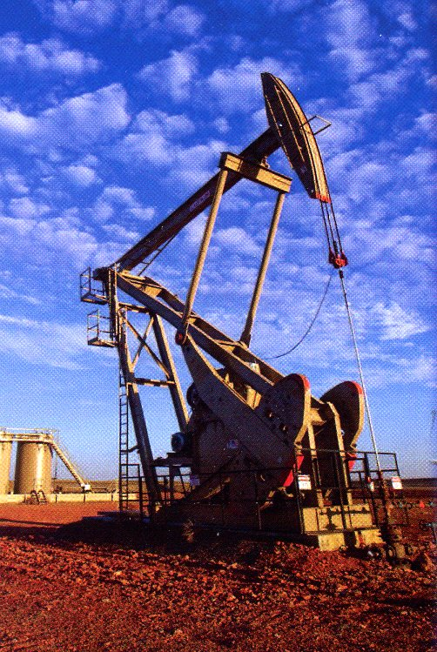

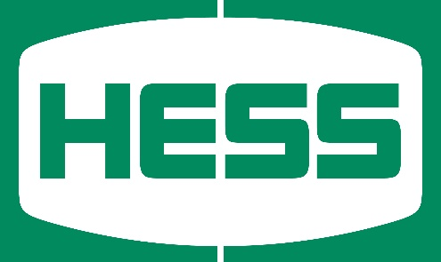

Sponsored by:

Hess Corporation

Summer 2022 Workshop Attendees

Monday – June 12th  
 through  
 Friday – June 16th

MSU-Billings Campus

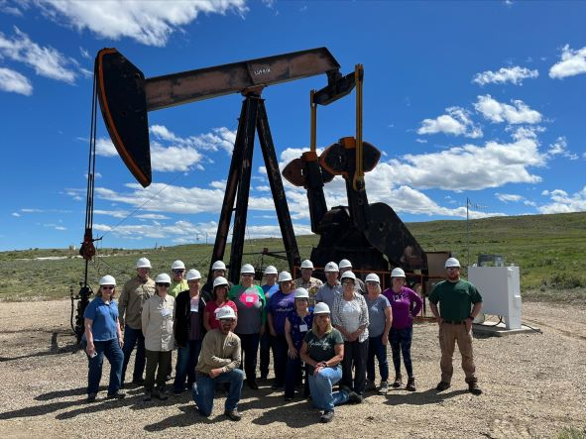

# Dates – Times - Location

# Summer 2023 Montana Petroleum Resources Workshop

**When**

Monday, June 12th through Friday, June 16th, 2023

**Times**

8:00am to 5:00pm daily (with lunch break) and includes two all-day bus field trips.

**Location**

Campus of Montana State University-Billings, Billings, MT

**Instructors**

Workshop is coordinated and instructed by current and former Montana Tech professors and assisted by other petroleum industry professionals from the area.

**What You Will Learn**

* How oil and gas are discovered and produced
* How crude oil is processed and delivered to consumers
* How the petroleum industry positively impacts our lives
* How you can present this information to students

**What You Will Take Away**

* A more complete knowledge of the petroleum industry
* A set of notes for classroom use
* An opportunity to earn OPI License Renewal Units or Graduate Professional Development credits

**Who Should Attend**

* Montana junior high and high school teachers, especially those teaching science and math-based classes
* Montana junior high and high school counselors

**Questions**

* For questions about the Workshop or registration, contact Lana at MANA Consulting in Butte:

**Phone: 406-782-2342**

**e-mail: ljpet@hotmail.com**

This Workshop provides an opportunity for Montana teachers to learn more about the Petroleum industry and its impact on the people and economy of Montana and the nation.

Hess Corporation is sponsoring the expenses of the Workshop. All lodging, meals, and course materials will be provided for the participants at no charge. Attendance at the Workshop can earn either 30 OPI License Renewal Units or 2 Graduate Professional Development credits from Montana State University-Billings (MSU-Billings).

Lodging, meals, and classroom facilities for the 5-day Workshop will be on the MSU-Billings campus.

Prompt registration is encouraged, as the Workshop will be limited to 20 participants.

# Registration:

|  |  |
| --- | --- |
|  | |
| Name | |
| Address | |
|  | |
|  | |
| Phone | |
| E-mail | |
| School | |
| Grade Level/Subject Taught |

Registration is limited to 20 participants, so please register early to save a spot. A refundable $100 registration deposit by check or money order must be submitted to hold all Registrations.

Hess Corporation will fund half of the cost of the Graduate Professional Development credits from MSU-Billings. Your half of the cost for the graduate credits ($99) will be payable to MSU-Billings at the end of the workshop.

MAKE REGISTRATION CHECKS PAYABLE TO:

“MANA Consulting, LLC - 2023 Petroleum Workshop”

Send completed Registration and Deposit by postal mail to the address shown to the right. All workshop details and information will be shared via email.

# MANA Consulting, LLC

# c/o Lana Petersen

# 2406 Locust

# Butte, MT 59701

# E-mail: ljpet@hotmail.com