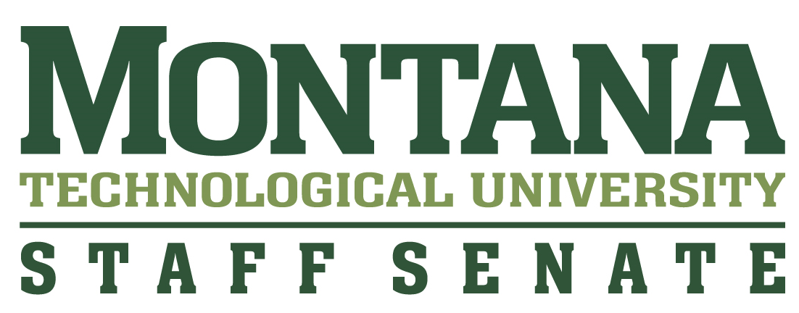

**Tips for writing award nominations – OUTSTANDING STAFF AWARD:**

Nominations are blinded before being given to the selection committee. Please help with this by limiting your use of your nominee’s name and pronouns in your answers.

The key to a well-written nomination is providing evaluators with specific information illustrating how the individual’s achievements have made a positive impact on you, your classmates, your department or the campus.

The selection committee relies on your words and examples to “see” your nominee’s attributes and contributions. Detailed information is essential. Don’t worry about using “fancy” words. Give examples of interaction and/or assistance given. Please spell out/define acronyms.

Make every sentence count. Write sentences that are concise and give specific detail.

**Things to think about when filling out the nominations form questions:**

**WHAT is the mission of Montana Tech?**

* <https://www.mtech.edu/about/strategic-plan/>

**WHAT did the nominee do?**

* Projects and/or activities that were outstanding and go beyond the nominee’s job description
* Any challenges or issues encountered were overcome with the nominee’s assistance

**HOW did the nominee do it?**

* Initiative and/or leadership
* Creativity and/or innovation
* Behaviors and/or attitudes

**WHAT were the results and/or impacts?**

* What did the nominee accomplish?
* Are there specific benefits derived from those efforts?

**SHOW THE “Outstanding”**

It is one thing to report what a person did, but the selection committee would like to know if those accomplishments were a normal part of the person’s job or something more.

* Was this an extra task, voluntarily taken on?

**BE CLEAR AND SPECIFIC**

* Be specific about what the nominee did and how it made a difference to you and others

**GATHER INPUT FROM OTHERS**

You can work together with one or more classmates to write the nomination for the staff member you feel is deserving of receiving the Outstanding Staff award.

**Example:**

**WEAK**

Nominee is a hard worker who goes above and beyond their job duties. In addition, Nominee is always

reliable, diligent, and has a willingness to help.

**STRONGER**

Although the person in this position doesn't typically give guidance, the nominee is a beneficial resource to me and many others. Living on campus in the residence halls is a big change in a student’s life, so the nominee’s help in that regard is very meaningful.